Operating Manual for International Postgraduate Students Online Course Selection
All the courses for international students are valid on the GMIS, students could view the courses through their eportal and select courses online. The following instruction is on the procedure of selecting courses online.
- Students are unable to be graded of their course unless they select the courses online;
- Students are suggested to read the curriculum carefully, clarify the credit requirements, and make a good plan when choosing courses;
- Students can only select the courses that are added in their curriculum;
- All the selected courses could not be withdrawn once the course selection finishes. The results will be recorded, please choose and withdraw courses carefully;
- If you meet any problems during course selection, please contact with your school coordinator or the Graduate School in time. These problems will not be dealt with when the course selection finishes.
- Duration of course selection：13:00 on September 6, 2022 to 14:00 on September 9, 2022.
Online Course Selection Procedure
- Log in to UESTC portal:
Log in to UESTC portal with the link: http://eportal.uestc.edu.cn and then click on “研究生系统”(GMIS). If you have any problems, please contact with Information Center (number: 61831184).
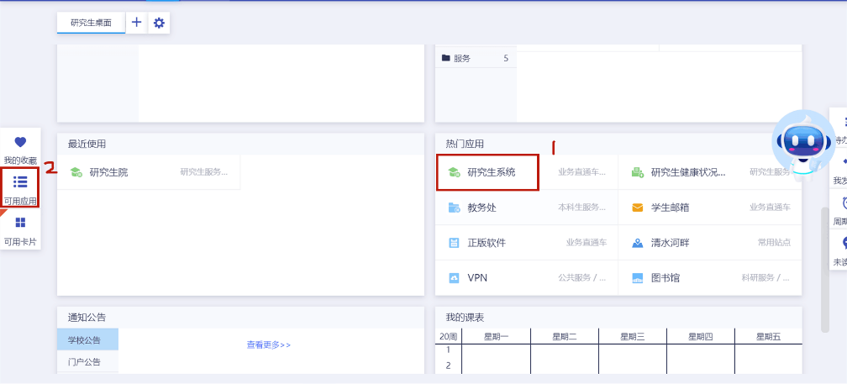
- Make the personal curriculum.
After entering the following page, you need to click “培养计划提交” (upload the curriculum) to make your curriculum under the guidance of your school and your supervisor. The evaluation, “exam” or “non-exam” is decided by the syllabus. The exam will show a percentile score, and the result of “non-exam” courses will only show whether it has passed Please note that only the curriculum enters the process of “审核通过”（It means your curriculum have been approved by your supervisor）can you select courses.
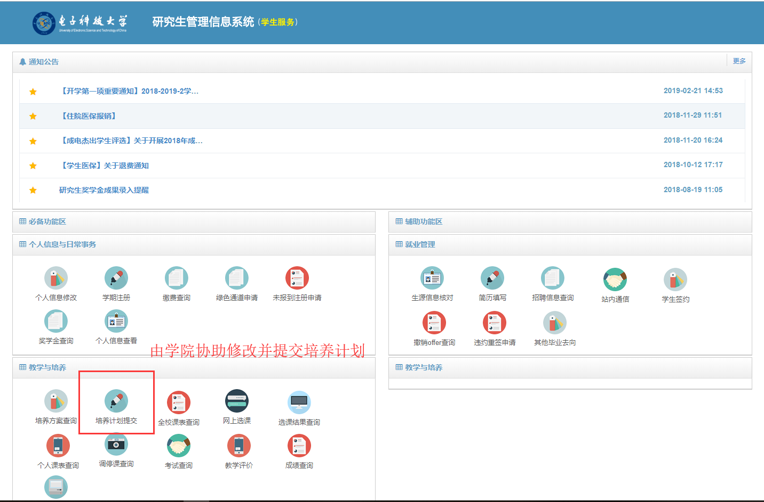
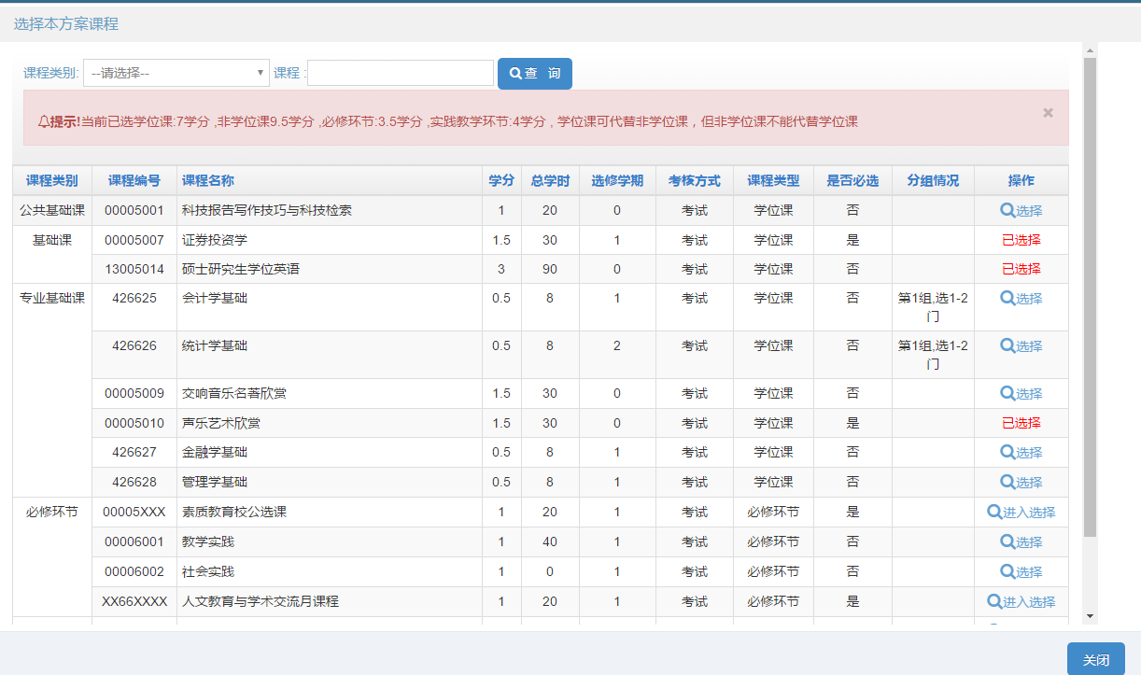
- Online course selection
Before selecting courses, you need to make sure that you have registered for the semester and your curriculum has been approved. Click on the "网上选课"（online course selection）column to select course. It should be noted that only one course can be selected at the same time slot, otherwise the system will prompt for "上课时间冲突"（conflict of class time）. Please make a good arrangement of you courses. When the number of students of a class reaches its limitation, you need to choose the same course instructed by another teacher or another course.
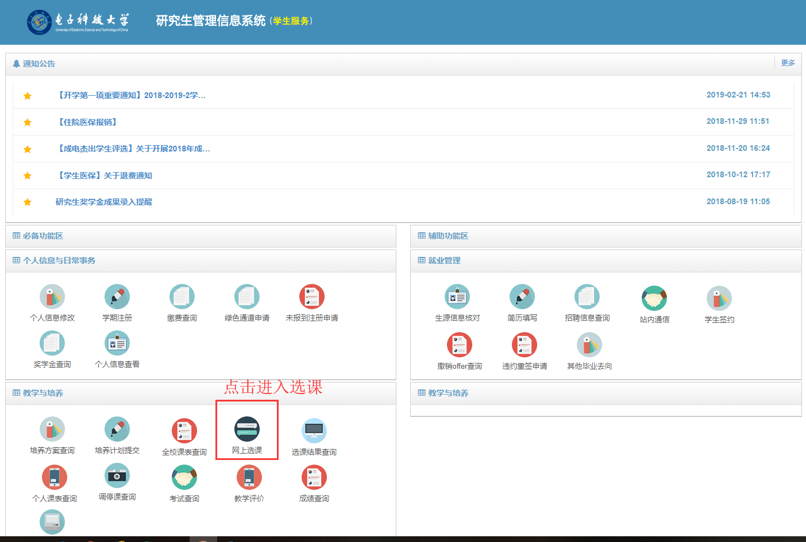
“可选课程”(course available) will display all optional courses added to the personal curriculum. The courses can be selected directly as long as it is not full, and the system generates the results of the course selection in real time.
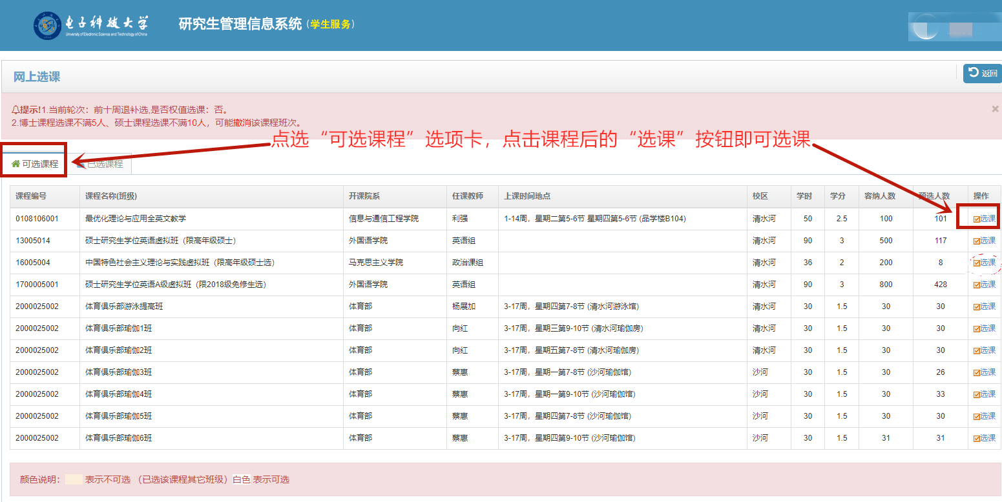
“已选课程”displays the selected courses, and if you want to withdraw it, click “退课” button on the right.
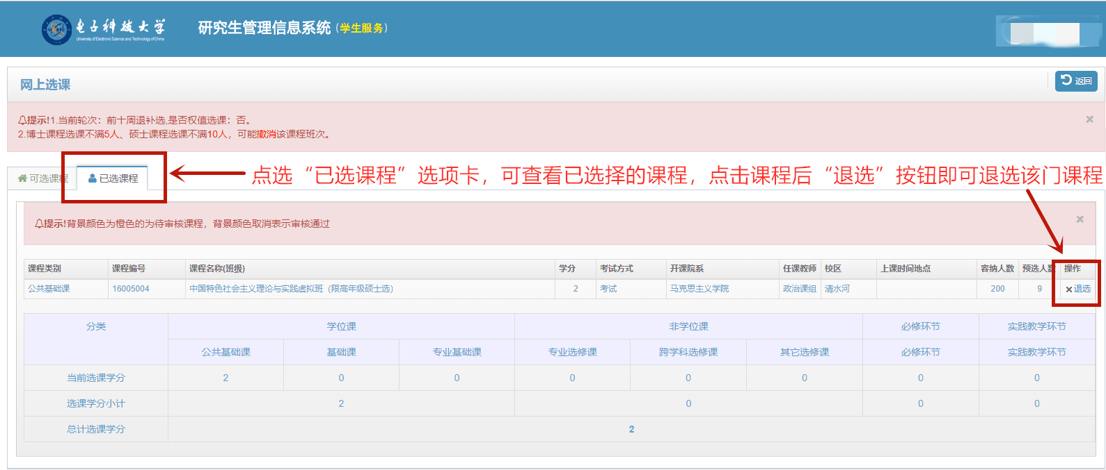
- Course selection result query
Students should check their course selection results in “选课结果查询”or“个人课表查询” (the squared places)
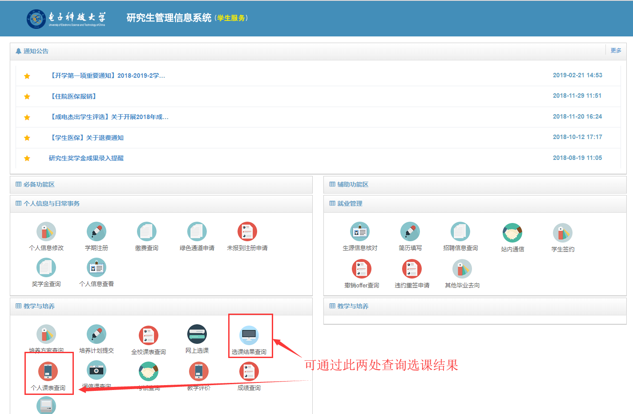
If there is any confusion on the instruction, feel free to contact with the coordinator in your school.

